* **This Resume, LinkedIn & Career Success Journal is the 2nd of 3 Success Journals in this Course. This Success Journal is the exercise book for Sections 24-41 of this course.**
* The purpose of this Success Journal is to make sure that your resume and LinkedIn profile increase your chances of getting an interview while completing the optional section that helps you to set career goals for what your resume will look like in 10 years.
* Please watch the videos in the course & then complete sections of this journal when instructed to do so.
* After completing this portion of the course (Sections 24-41) and this Success Journal, you will have the confidence to do exceptionally well in your interview! After you complete this journal, move on to Journal #3. Thanks

Part 2 of 3: Resume, LinkedIn and Career

Success

Journal

Your Blueprint

to Your Dream Job

From the Course:

*The Complete Job, Interview, Resume, Network & New Career Guide*

Please use the PDF version of this document if you don’t have access to Microsoft Word or if you prefer a PDF formatted document for the device you are using to take this course. Thanks

Welcome to your **Resume, LinkedIn and Career Success Journal** (the second of 3 success journals in this course)!

Please only complete the exercises in this journal when instructed to do so (meaning when I mention to please do so in the videos). Thanks

Please note that this *Resume, LinkedIn and Career Success Journal* corresponds to Sections 24 – 41 of the course.

After completing “*Part 1 of 3: Interview Success Journal” and* “*Part 2 of 3: Resume, LinkedIn and Career Success Journal,” then* please complete the 3rd Journal, which corresponds to Sections 42 – 50 in the course and is called: **Part 3 of 3: Networking Success Journal**

I humbly recommend taking the course in order and completing the 3 Success Journals in order because you might learn what to include and what not to include on your resume and optimized LinkedIn profile based on how you answer the interview questions in Part 1 of this course.

As always, I am here to help if you have any questions.

Enjoy the course! Thanks

Chris Haroun

: )

## **Section #24**:

## Building the Perfect Resume, LinkedIn Profile + Goal Setting Workshop

## **exercise #24:**

## What is wrong with this resume?

In this exercise, please identify the 25 things wrong with the resume shown on the next page. We will cover content later….just look for formatting, grammatical and spelling errors. Please enter your answers on the table listed on the page after the resume. Thanks

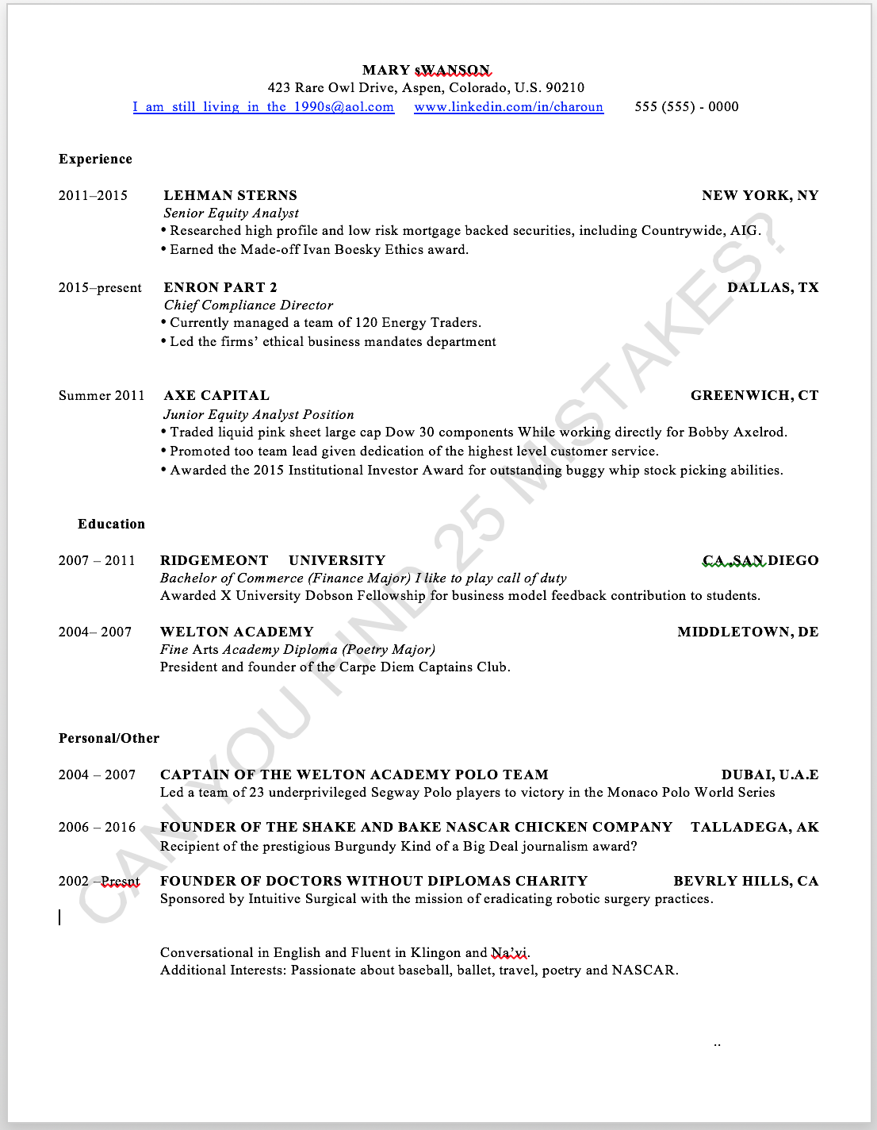

Please find 25 formatting, grammar and spelling mistakes and list them on the next page. Thanks

|  |  |
| --- | --- |
| **What are 25 Mistakes in the Resume on the Previous Page?** | |
| 1: | 14: |
| 2: | 15: |
| 3: | 16: |
| 4: | 17: |
| 5: | 18: |
| 6: | 19: |
| 7: | 20: |
| 8: | 21: |
| 9: | 22: |
| 10: | 23: |
| 11: | 24: |
| 12: | 25: |
| 13: |  |

**Next Step: Please watch the next video in the course before doing the next exercise. Thanks**

## **Section #25**:

## Goal Setting Workshop

## **exercise #25.1:**

## Part 1/4: Writing Down Your 10 Year Goals

There are 4 Parts to this Goal Setting Exercise: Part 1, Part 2 and Part 3. Please start with Part 1 and then watch the next video before starting Part 2. Thanks:

**Part 1 of 4 of the Goal Setting Exercise:**

**Writing Down Your 10 Year Goals**

Please don’t conservative with this exercise. Writing down our 10 year goals will really help us with building our resume and amazing networking skills later in the course. Many of my students or executives that I train use this exercise to help them understand what their passion is, which often results in an eventual [HAPPIER] career change. If you write down your goals, the likelihood that you achieve them increases significantly so please take your time with this and enjoy the exercise!

I want you to please think big…and then think **BIGGER!**

With that in mind, please write down your ONE HUNDRED (that’s right) ONE HUNDRED 10 year goals (professional, educational and personal goals….why personal too? Because you won’t have a job then….you will have a passion then)! Please think HUGE!

**Goals can be:**

* work/professional goals,
* education goals,
* charity goals,
* health goals,
* make the world a better place goals,
* spiritual goals,
* happiness goals,
* where you want to live goals,
* etc.

There are 100 boxes to fill out below. I put many inspirational quotes for you to enjoy while you write your 100 goals (to help with your UNSTOPPABLE MOMENTUM in completing this life altering exercise : )

**The most brilliant entrepreneurs like Steve Jobs would go on long walks to soul search and think of business ideas. Consider going on a long walk while you complete this section:**

|  |
| --- |
| 1: |
| 2: |

*"Once you realize that everything around you was created by people that are no smarter than you, you’ll never be the same"* -Steve Jobs

|  |
| --- |
| 3: |
| 4: |

*“The secret of getting ahead is getting started.” -Mark Twain*

|  |
| --- |
| 5: |
| 6: |

*“It always seems impossible until its done.” -Nelson Mandela*

|  |
| --- |
| 7: |
| 8: |

*"Your time is limited, so don't waste it living someone else's life.” -Steve Jobs*

*“I know where I'm going and I know the truth, and I don't have to be what you want me to be. I'm free to be what I want.” -Muhammad Ali*

|  |
| --- |
| 9: |
| 10: |

*“I'd rather attempt to do something great and fail than to attempt to do nothing and succeed.”-Robert H. Schuller*

|  |
| --- |
| 11: |
| 12: |

*“Opportunity does not knock, it presents itself when you beat down the door.” -Kyle Chandler*

|  |
| --- |
| 13: |
| 14: |

*"Everything you can imagine is real." -Pablo Picasso*

|  |
| --- |
| 15: |
| 16: |

*"Someone is sitting in the shade today because someone planted a tree a long time ago."*

*-Warren Buffett*

*“Someday is not a day of the week.” -Denise Brennan-Nelson*

|  |
| --- |
| 17: |
| 18: |
| 19: |

*"Don't count the days, make the days count." -Muhammad Ali*

|  |
| --- |
| 20: |
| 21: |

*"In the middle of every difficulty lies opportunity." -Albert Einstein*

|  |
| --- |
| 22: |
| 23: |

*“Accept the challenges so that you can feel the exhilaration of victory.” -George S. Patton*

|  |
| --- |
| 24: |
| 25: |

*"When you cease to dream you cease to live. "* -Malcolm Forbes

*“The best way to predict the future is to invent it.” -Alan Kay*

|  |
| --- |
| 26: |
| 27: |

*“You can never quit. Winners never quit, and quitters never win.’ - Ted Turner*

|  |
| --- |
| 28: |
| 29: |

*“Big shots are only little shots who keep shooting.” - Christopher Morley*

|  |
| --- |
| 30: |
| 31: |

*“Well done is better than well said.” -Benjamin Franklin*

|  |
| --- |
| 32: |
| 33: |

*“Only I can change my life. No one can do it for me.” - Carol Burnett*

|  |
| --- |
| 34: |
| 35: |

*“You can't wait for inspiration. You have to go after it with a club.’ -Jack London*

*“The purpose of our lives is to be happy.” -Dalai Lama*

|  |
| --- |
| 36: |
| 37: |

*“Perseverance is failing 19 times and succeeding the 20th.” -Julie Andrews*

|  |
| --- |
| 38: |
| 39: |

*"* *Failure is another steppingstone to greatness."* -Oprah Winfrey

|  |
| --- |
| 40: |
| 41: |

*"Don't let the fear of striking out hold you back.” -Babe Ruth*

|  |
| --- |
| 42: |
| 43: |

*“If you don't like how things are, change it! You're not a tree.” -Jim Rohn*

|  |
| --- |
| 44: |
| 45: |

*“The more things you do, the more you can do.” -Lucille Ball*

*“Do what you love and the money will follow.” -Marsha Sinetar*

|  |
| --- |
| 46: |
| 47: |

*"You miss 100% of the shots you don't take." -Wayne Gretzky*

|  |
| --- |
| 48: |
| 49: |

*"We must accept finite disappointment, but never lose infinite hope.” -Martin Luther King, Jr.*

|  |
| --- |
| 50: |
| 51: |

*“If you don't ask, you don't get.” - Stevie Wonder*

|  |
| --- |
| 52: |
| 53: |

*“I am not afraid... I was born to do this.” -Joan of Arc*

*“Your imagination is your preview of life’s coming attractions.” -Albert Einstein*

|  |
| --- |
| 54: |
| 55: |

*“What keeps me going is goals.” -Muhammad Ali*

|  |
| --- |
| 56: |
| 57: |

*“I can accept failure, everyone fails at something. But I can't accept not trying.” -Michael Jordan*

|  |
| --- |
| 58: |
| 59: |

*" You must expect great things of yourself before you can do them." -Michael Jordan*

|  |
| --- |
| 60: |
| 61: |

*"The more you dream, the farther you get.” -Michael Phelps*

|  |
| --- |
| 62: |
| 63: |

*“Happiness is when what you think, what you say, and what you do are in harmony.”*

*-Mahatma Gandhi*

*The more I want to get something done, the less I call it work.” -Richard Bach*

|  |
| --- |
| 64: |
| 65: |

*“The mind is everything. What you think you become.” -Buddha*

|  |
| --- |
| 66: |
| 67: |

*"It does not matter how slowly you go, so long as you do not stop." -Confucius*

|  |
| --- |
| 68: |
| 69: |

*"If you want to be happy, set a goal that commands your thoughts, liberates your energy, and inspires your hopes.” -Andrew Carnegie*

|  |
| --- |
| 70: |
| 71: |

*“We may encounter many defeats but we must not be defeated.” -Maya Angelou*

*“To avoid criticism, do nothing, say nothing, be nothing.” -Elbert Hubbard*

|  |
| --- |
| 72: |
| 73: |

*"* *The two most important days in your life are the day you are born and the day you find out why."*

-Mark Twain

|  |
| --- |
| 74: |
| 75: |

*“Your work is going to fill a large part of your life, and the only way to be truly satisfied is to do what you believe is great work. And the only way to do great work is to love what you do. If you haven't found it yet, keep looking. Don't settle. As with all matters of the heart,*

*you'll know when you find it.” - Steve Jobs*

|  |
| --- |
| 76: |
| 77: |

*"Two roads diverged in a wood, and I — I took the one less traveled by. And that has made all the difference.” -Robert Frost (from his poem "The Road Not Taken")*

|  |
| --- |
| 78: |
| 79: |

*“The journey of a thousand miles begins with one step.” -Lao Tzu*

*“Dream big and dare to fail.” -Norman Vaughan*

|  |
| --- |
| 80: |
| 81: |

*“Tough times never last, but tough people do.” -Dr. Robert Schuller*

|  |
| --- |
| 82: |
| 83: |

*“There is only one success: to be able to spend your life in your own way.” -Christopher Morley*

|  |
| --- |
| 84: |
| 85: |

*“The power of imagination makes us infinite.” -John Muir*

|  |
| --- |
| 86: |
| 87: |

*“Believe and act as if it were impossible to fail.” -Charles Kettering*

|  |
| --- |
| 88: |
| 89: |

*“Every strike brings me closer to the next home run.” -Babe Ruth*

*"* *The biggest risk is not taking any risk... In a world that's changing really quickly, the only strategy that is guaranteed to fail is not taking risks."* - Mark Zuckerberg

|  |
| --- |
| 90: |

*“Go confidently in the direction of your dreams and live the life you have imagined.”*

*-Henry David Thoreau*

|  |
| --- |
| 91: |

*“Believe you can and you’re halfway there.” -Theodore Roosevelt*

|  |
| --- |
| 92: |

*“Never let your memories be greater than your dreams.” -Doug Ivester*

|  |
| --- |
| 93: |

*"If something is important enough, even if the odds are against you, you should still do it. -Elon Musk*

|  |
| --- |
| 94: |

*“It wasn’t raining when Noah built the ark.” -Howard Ruff*

|  |
| --- |
| 95: |

*“Don’t wait. The time will never be just right.” -Napoleon Hill*

|  |
| --- |
| 96: |

*“It’s not whether you get knocked down, it’s whether you get up.” -Vince Lombardi*

*“Try not. Do, or do not. There is no try.” -Yoda*

|  |
| --- |
| 97: |

*“Everything you’ve ever wanted is on the other side of fear.” -George Addair*

|  |
| --- |
| 98: |

*“If you aren’t going all the way, why go at all? -Joe Namath*

|  |
| --- |
| 99: |

*“A year from now you may wish you had started today.” -Karen Lamb*

*“Change your thoughts and you change your world.” -Norman Vincent Peale*

|  |
| --- |
| 100: |

Let’s do one more to make it 101!

*“It is never too late to be what you might have been.” -George Eliot*

|  |
| --- |
| 101 |

**Great work!!!! I hope you feel inspired and empowered! After you finish with this section (Part 1 of 4) please watch the next video for instructions on what to do next before turning to the next page.**

## **Section #25**:

## Goal Setting Workshop

## **exercise #25.2:**

## Part 2/4: Categorizing Your Goals

**Part 2 of 4 of the Goal Setting Exercise:**

**Categorizing Your Goals**

Now we need to categorize all of the goals you just wrote down in the previous exercise….so please write down one of the following 3 letters beside all of the 101 goals that you just wrote down in the previous exercise:

**W** (for **W**ork Experience Goal)

**E** (for **E**ducation Goal)

**P/O** (for **P**ersonal/**O**ther Goal)

**After you finish with this section (Part 2 of 4) please watch the next video for instructions on what to do next before turning to the next page.**

## **Section #25**:

## Goal Setting Workshop

## **exercise #25.3:**

## Part 3/4: FiLLing the ‘gap’

**Part 3 of 4 of the Goal Setting Exercise:**

**Filling the Gap in Order to Achieve Your Goals:**

Based on the goals you wrote down in Part 1 of this exercise, on the next few pages please write down:

4 (or fewer) things you would like to accomplish within 10 years in the **Work Experience** table (shown after my examples below).

3 (or fewer) things you would like to accomplish within 10 years (in the **Education** table (shown after my examples below).

5 or fewer things you would like to accomplish within 10 years (please be brief) in the **Personal / Other** table (shown after my examples below).

Then after you have written down your goals in the left hand column, please write down in the right hand column what you need to achieve to make that goal a reality in 10 years (meaning what ‘gap’ do you need to fill)?

**Here are examples of completing the Work Experience, Education and Personal / Other tables:**

For example, (here is a brief excerpt from the **Work** **Experience** section):

|  |  |
| --- | --- |
| **EXAMPLE: Work Experience Excerpt:** | |
| Goal | How do I fill the gap so I can achieve the goal? |
| 1: Become a Partner at Goldman Sachs in 2026 | -I will get a finance summer internship at a great finance company.  -I will learn more about finance online via online courses etc.  Not sure of the other requirements yet…. -I will set up a meeting with employees from Goldman Sachs and ask them for help…note I will teach you the easy way to get these meetings in the networking portion of this course. |

Here is another section (brief excerpt from the **Education** section):

|  |  |
| --- | --- |
| **EXAMPLE: Education Section Excerpt:** | |
| Goal | How do I fill the gap so I can achieve the goal? |
| 1: MBA from Harvard Business School in 2020 | -I will call the school’s admissions and ask when I can visit the school and sit in on classes [easy to do….please make the call!].  Not sure of the other requirements…. -I will set up a meeting with alumni from Harvard Business School and ask them for help… note I will teach you the easy way to get these meetings in the networking portion of this course. |

Here is another example (brief excerpt from the **Personal/Other** section):

|  |  |
| --- | --- |
| **EXAMPLE: Personal / Other Section Excerpt:** | |
| Goal | How do I fill the gap so I can achieve the goal? |
| 1: Start a charity to help underprivileged youth reach their full potential called “PayItForwardToday.org” in 2016 | -I will create a Facebook page to recruit people to help me with this.  -I will improve the lives of many underprivileged youth that didn’t have the same opportunities as I did. I will make a difference.  Not sure of the other requirements yet…. -I will set up a meeting with notable alumni from my school or from my home town that have started charities and ask them for guidance…note I will teach you the easy way to get these meetings in the networking portion of this course. |

Now it’s your turn. Please complete the 3 tables below (using the examples above as a guide).

|  |  |
| --- | --- |
| **Work Experience**: Based on the goals you wrote down in Part 1 of this exercise, please write down 4 (or fewer) things in this table that you would like to see in 10 years on the **Work Experience Section** of your resume (complete the left side of the table below and please be brief). Then please sort it by date – meaning if you have one job that starts in 2025 and another one that starts in 2017, put the job that starts in 2017 after the job that starts in 2025.  Then after you have written down the 4 (or fewer) **Work Experience** goals in the left hand column, please write down in the right hand column what you need to achieve to make that goal a reality (meaning what ‘gap(s)’ do you need to fill per examples listed earlier in this section. | |
| Goal | How do I fill the gap so I can achieve the goal? |
| 1: |  |
| 2: |  |
| 3: |  |
| 4: |  |

|  |  |
| --- | --- |
| **Education**: Based on the goals you wrote down in Part 1 of this exercise, please write down 3 (or fewer) things in this table that you would like to see in 10 years on the **Education Section** of your resume (complete the left side of the table below and please be brief). Then please sort it by date – meaning if you have one job that starts in 2025 and another one that starts in 2017, put the job that starts in 2017 after the job that starts in 2025.  Then after you have written down the 3 (or fewer) **Education** goals in the left hand column, please write down in the right hand column what you need to achieve to make that goal a reality (meaning what ‘gap(s)’ do you need to fill per examples listed earlier in this section. | |
| Goal | How do I fill the gap so I can achieve the goal? |
| 1: |  |
| 2: |  |
| 3: |  |

|  |  |
| --- | --- |
| **Personal / Other**: Based on the goals you wrote down in Part 1 of this exercise, please write down 5 (or fewer) things in this table that you would like to see in 10 years on the **Personal/Other Section** of your resume (complete the left side of the table below and please be brief). Then please sort it by date – meaning if you have one job that starts in 2025 and another one that starts in 2017, put the job that starts in 2017 after the job that starts in 2025.  Then after you have written down the 5 (or fewer) **Personal/Other** goals in the left hand column, please write down in the right hand column what you need to achieve to make that goal a reality (meaning what ‘gap(s)’ do you need to fill per examples listed earlier in this section. | |
| Goal | How do I fill the gap so I can achieve the goal? |
| 1: |  |
| 2: |  |
| 3: |  |
| 4: |  |
| 5: |  |

**After you finish with this section (Part 3 of 4) please watch the next video for instructions on what to do next before turning to the next page.**

## **Section #25**:

## Goal Setting Workshop

## **exercise #25.4:**

## Part 4/4: Finishing the Simple Perfect Resume

**Part 4 of 4 of the Goal Setting Exercise:**

**Finishing the Simple Perfect Resume**

Please open the document attached to this lecture called **Simple_Resume_Template.DOC**

Please copy and paste your Work Experience in 10 years, your Education in 10 Years and Your Personal / Other in 10 years from Part 2 of this exercise (per the image below). Also please complete your name, address (the exact address you want to live in in 10 years) & interests as well:

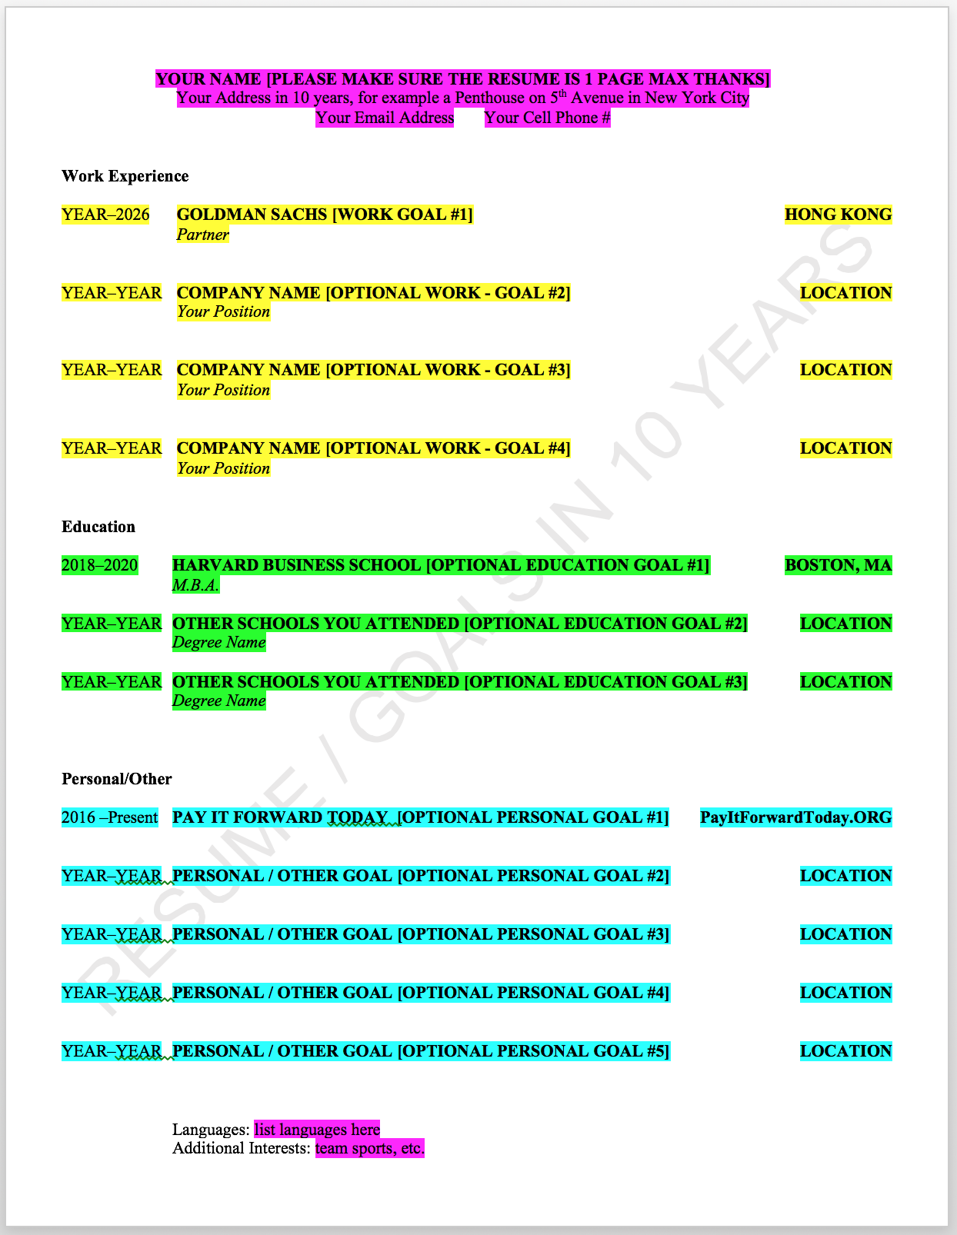

Great work! I hope you are fired up to make this a reality!!!!

Please update your 10-year resume that you just created every 2 years (I have been doing this since the late 90’s). Doing this helps you achieve your goals I promise! I achieved many of my goals, with the exception of winning an Olympic gold medal in pole vaulting, which I plan to win much later in life. Kidding as I suck at sports!

**5 Ways to Ensure that You Achieve your 10 Year Goals Checklist:**

* Tell your family and best friends about your goals because telling them makes you more inclined or slightly pressured in a good way to work harder to achieve your goals.
* Print out your 10 year simple perfect resume and seal it in a self addressed stamped envelope. Give it to your Mom or Dad or a friend and tell them to mail it to you in one year.
* Print out your simple perfect resume and literally tape it on your mirror.
* Carry a printed version of your resume and always keep it in your wallet or in your purse.
* Copy and past the contents of your simple perfect resume and put it in your calendar or Gmail calendar. In the notes field of that calendar paste your 10-year resume contents and have this calendar entry repeat daily so you can keep focusing on achieving your 10 year goals.

**Again, please share with all of us what your goals are in the general message fields in this course as we can all inspire each other! Thanks!**

**Next Step: Please watch the next video in the course before doing the next exercise. Thanks**

## **Section #26**:

## Impactful Words & Job Titles to Include on Your Resume

## **exercise #26:**

## Using Impactful Words & in the Right Tense

Please identify 10 incorrect tense and incorrect (or redundant) ways to start a line item on the resume on the next page. After you have identified the 10 issues, please watch the next video in the course for a discussions of the answers. Thanks

|  |  |
| --- | --- |
| **What are 10 Mistakes in the Resume on the Next Page?** | |
| 1: | 6: |
| 2: | 7: |
| 3: | 8: |
| 4: | 9: |
| 5: | 10: |

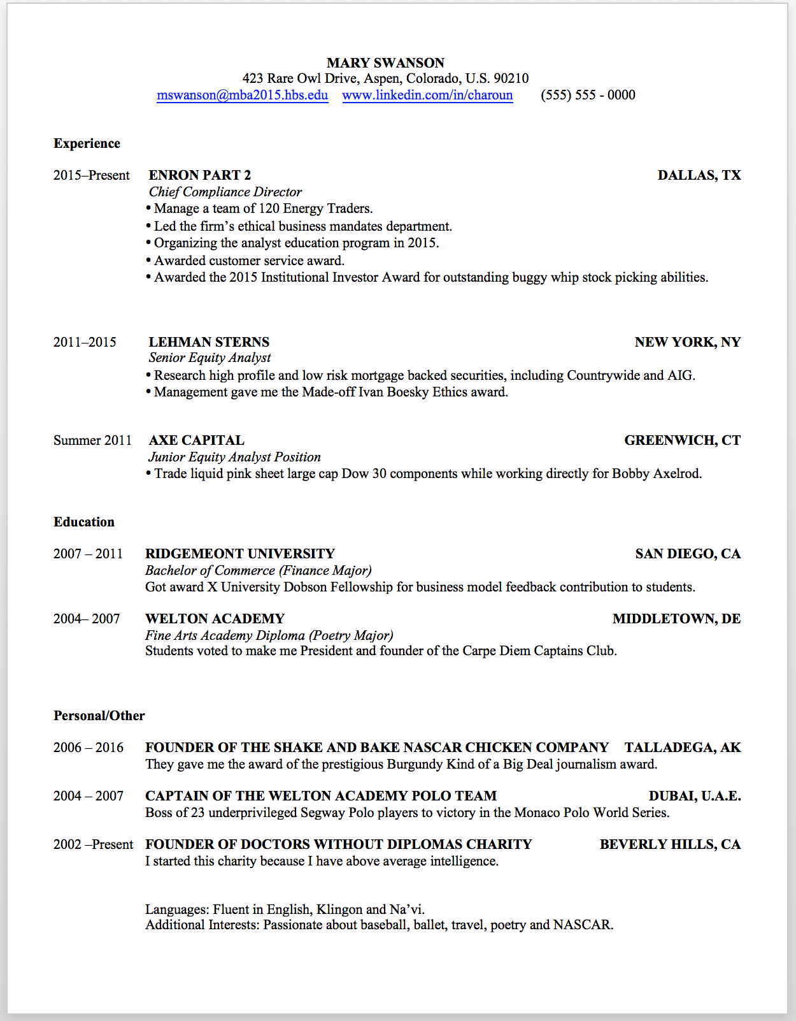

Please watch the next video lecture for a discussion of the answers to this exercise.

## **Section #27:**

## Your Biggest Accomplishments in Your Life (So Far) so we can eventually list them on your resumE **exercise #27:**

## What Are Your Accomplishments that are Impressive, Interesting or Unique

On the left hand side of the table below, please try your best to list 20 things that you have accomplished that are either impressive and/or interesting and/or unique. Then complete the 4 right hand columns

|  |  |  |  |  |
| --- | --- | --- | --- | --- |
| **Please list your 20 biggest accomplishments in this column (or as many as you can).** | **Will this be impressive to the interviewer?**  **Select**  **Yes or No** | **Will this be interesting to the interviewer.**  **Select**  **Yes or No** | **Will the interviewer think this is unique?**  **Select**  **Yes or No** | **Pick one category for this accomplishment**  **Select**  **either Education or Experience or Personal(Other)** |
| 1: | Yes / No | Yes / No | Yes / No | Education /  Experience /  Personal (Other) |
| 2: | Yes / No | Yes / No | Yes / No | Education /  Experience /  Personal (Other) |
| 3: | Yes / No | Yes / No | Yes / No | Education /  Experience /  Personal (Other) |
| 4: | Yes / No | Yes / No | Yes / No | Education /  Experience /  Personal (Other) |
| 5: | Yes / No | Yes / No | Yes / No | Education /  Experience /  Personal (Other) |
| 6: | Yes / No | Yes / No | Yes / No | Education /  Experience /  Personal (Other) |
| 7: | Yes / No | Yes / No | Yes / No | Education /  Experience /  Personal (Other) |
| 8: | Yes / No | Yes / No | Yes / No | Education /  Experience /  Personal (Other) |
| 9: | Yes / No | Yes / No | Yes / No | Education /  Experience /  Personal (Other) |
| 10: | Yes / No | Yes / No | Yes / No | Education /  Experience /  Personal (Other) |
| 11: | Yes / No | Yes / No | Yes / No | Education /  Experience /  Personal (Other) |
| 12: | Yes / No | Yes / No | Yes / No | Education /  Experience /  Personal (Other) |
| 13: | Yes / No | Yes / No | Yes / No | Education /  Experience /  Personal (Other) |
| 14: | Yes / No | Yes / No | Yes / No | Education /  Experience /  Personal (Other) |
| 15: | Yes / No | Yes / No | Yes / No | Education /  Experience /  Personal (Other) |
| 16: | Yes / No | Yes / No | Yes / No | Education /  Experience /  Personal (Other) |
| 17: | Yes / No | Yes / No | Yes / No | Education /  Experience /  Personal (Other) |
| 18: | Yes / No | Yes / No | Yes / No | Education /  Experience /  Personal (Other) |
| 19: | Yes / No | Yes / No | Yes / No | Education /  Experience /  Personal (Other) |
| 20: | Yes / No | Yes / No | Yes / No | Education /  Experience /  Personal (Other) |

**Next Step: Please watch the next video in the course before doing the next exercise. Thanks**

## **Section #28:**

## Creating the 1st of 3 Sections of Your Resume (The Experience Section)

## **exercise #28:**

## Creating the WORK Experience Section of Your Resume (the 1st of 3 parts of your resume).

We will worry more about formatting later. For now, we are focused on the content of your resume.

In terms of the **Work Experience** (some call it just ‘**Experience**’) section of your resume, I want you to complete the section below. Try to reuse or copy + paste items that you already covered in **Exercise #28** into the table below (if applicable) in the right hand column.

Please try your best to include the **Impactful Words** (or similar words from [www.thesaurus.com)](http://www.thesaurus.com)) that we covered earlier in the course (if possible and if applicable) in the right hand column in the exercise below. Try to also make sure that what you list or the way you list your work experience is applicable to the company you are applying to (and hopefully gets you closer to you 10 year goals or career change/new career goals).

If you received an award, were promoted or have a leadership position, please make sure to mention this (per the hypothetical example in the table listed below).

|  |  |
| --- | --- |
| **Work Experience Section** List your experience and sort it by most recent (meaning list your current job if you have one first). | |
| **Work Experience** (If applicable….if you don’t have full time work experience, write down your part-time work experience or summer jobs if you had any). | Copy and paste the **accomplishments** that you documented in the previous exercise in this column that is applicable to the **Work Experience** item that you list on the left side of this table (if available).  If you have multiple accomplishments for the same job, then I want you to list the ones **first** that you selected ‘YES’ for in the previous exercise for **all 3** of these items: Impressive + Interesting + Unique.  Then list the accomplishments that only had 2 qualities **second** (i.e., only Impressive + Interesting).  Then, lastly (if applicable), list the accomplishments that had only 1 quality **last** (i.e., Impressive).  Also, make sure to explain in as few words as possible, what your role was (see the example below) while using **Impactful Words** at the start of each bullet point or line item if possible).  Lastly, if this was a job in the past, use the correct tense (i.e., in the example below, instead of starting the word with ‘Conduct’, start with ‘Conducted.’) |
| Example:  Company Name = Morgan Sachs, Inc.  My Most Recent Title: Equity Analyst  Years I worked @ this firm: 2008 - Present | -Conduct comprehensive research on market leading domestic and international virtual reality companies.  -Awarded the 2009 Institutional Investor Award for outstanding stock picking abilities.  -Promoted to **team** lead at Morgan Sachs’ P.E.I. office given **dedication** of ensuring that our office has the highest **customer service** record.  *[Please max out at 140 or so characters; underlined words in this example are strength words which you can include if you want. The yellow highlighted words are* ***Impactful Words****].* |
| 1:  Company Name =  My Most Recent Title =  Years I worked @ this firm: |  |
| 2:  Company Name =  My Most Recent Title =  Years I worked @ this firm: |  |
| 3:  Company Name =  My Most Recent Title =  Years I worked @ this firm: |  |
| 4:  Company Name =  My Most Recent Title =  Years I worked @ this firm: |  |
| 5:  Company Name =  My Most Recent Title =  Years I worked @ this firm: |  |
| 6:  Company Name =  My Most Recent Title =  Years I worked @ this firm: |  |
| 7:  Company Name =  My Most Recent Title =  Years I worked @ this firm: |  |
| 8:  Company Name =  My Most Recent Title =  Years I worked @ this firm: |  |
| 9:  Company Name =  My Most Recent Title =  Years I worked @ this firm: |  |
| 10:  Company Name =  My Most Recent Title =  Years I worked @ this firm: |  |

Don’t worry if you listed too many items as you can combine them or remove the older ones if you want per the video discussion in this lecture.

**Next Step: Please watch the next video in the course before doing the next exercise. Thanks**

## **Section #29:**

## Creating the 2nd of 3 Sections of Your Resume (The Education Section)

## **exercise #29:**

## Creating the Education Section of Your Resume (the 2nd of 3 parts of your resume).

We will worry about formatting in a few sections. For now, we are focused on the content of your resume.

In terms of the **Education** section of your resume, I want you to please complete the section below. Try to reuse or copy + paste items that you already covered in **Exercise #28** into the table below (if applicable) in the right hand column.

Please try your best to include the **Impactful Words** (or similar words from [www.thesaurus.com)](http://www.thesaurus.com)) that we covered earlier in the course (if possible and if applicable) in the right hand column in the exercise below.

If you received an award, scholarship, founded an extracurricular activity or had a leadership position at school, please make sure to mention this (per the hypothetical example in the table listed below).

|  |  |
| --- | --- |
| **Education Section** List your education and sort it by most recent (meaning the most recent school that you attended or are currently attending). | |
| **Education** (If applicable, please write down your education, including all schools that you have attended – even if you went on exchange which is an interesting topic to discuss in an interview). | Copy and paste the **accomplishments** that you documented in Exercise #28 (if applicable) in this column that is applicable to the **Education** item that you list on the left side of this table (if available).  If you have multiple accomplishments while you were at the same school, then I want you to list the ones **first** that you selected ‘YES’ for in the previous exercise for **all 3** of these items: Impressive + Interesting + Unique.  Then list the accomplishments that only had 2 qualities **second** (i.e., only Impressive + Interesting).  Then, lastly (if applicable), list the accomplishments that had only 1 quality **last** (i.e., Impressive).  Also, make sure to explain in as few words as possible, what your degree is/was while using **Impact Words** if possible. |
| Example:  School Name = University of Bautista  Degree Obtained (or to obtain)= Bachelor of Arts  Years you attended this school= 2008 - 2012 | -Majored in Philosophy, and received an award for publishing a paper on The Philosophy of Yogi Berra and the Interpretation of Mr. Berra’s Prophetic Baseball Poetry.  -Awarded baseball scholarship and given the Encarnacion Award for **team** leadership, **dedication** and **passion** for the sport. |
| 1:  School Name =  Degree Obtained (or to obtain)=  Years you attended this school= |  |
| 2:  School Name =  Degree Obtained (or to obtain)=  Years you attended this school= |  |
| 3:  School Name =  Degree Obtained (or to obtain)=  Years you attended this school= |  |
| 4:  School Name =  Degree Obtained (or to obtain)=  Years you attended this school= |  |
| 5:  School Name =  Degree Obtained (or to obtain)=  Years you attended this school= |  |

Don’t worry if you listed too many items as you can combine them or remove the older ones if you want per the video discussion in this section. For example, I don’t list high school anymore on my resume, but I did a few years ago when I was 25. I am currently 27. Fine I’m 44 but I feel like I am 27 ; )

**Next Step: Please watch the next video in the course before doing the next exercise. Thanks**

## **Section #30:**

## Creating the 3rd of 3 Sections of Your Resume (The Personal/Other Section)

## **exercise #30:**

## Creating the Personal/Other Section of Your Resume (the 3rd of 3 parts of your resume).

We will worry about formatting in the next section. This is the last section on creating content for the resume.

In terms of the **Personal** section of your resume, I want you to please complete the section below. Try to reuse or copy + paste items that you already covered in **Exercise #28** into the table below (if applicable) in the right hand column.

Please try your best to include the **Impactful Words** (or similar words from [www.thesaurus.com)](http://www.thesaurus.com)) that we covered earlier in the course (if possible and if applicable) in the right hand column in the exercise below.

Please don’t list any political affiliations as you 50% of people will love you and potentially vice versa! : )

If you do charity work, play **team** sports, and have other passions/interests, please mention this (per the hypothetical example in the table listed below).

Make sure to list the charity work you are passionate and proud of. List activates where you had a leadership function that have nothing to do with school or work. Also list your passions and enjoy this exercise!

|  |  |
| --- | --- |
| **Personal/Other Section** List your extracurricular activities and anything that the interviewer will find interesting. | |
| **Personal / Other** Please list items that make you well rounded too…..meaning you love team sports, travel etc. What are your passions? What will make you light up and seem energized and happy and interesting to talk to in your interviews? | Copy and paste the **accomplishments** that you documented in Exercise #28 (if applicable) in this column that is applicable to the **Personal / Other** item that you list on the left side of this table (if available).  If you have multiple personal/other accomplishments, then I want you to list the ones **first** that you selected ‘YES’ for in the previous exercise for **all 3** of these items: Impressive + Interesting + Unique.  Then list the accomplishments that only had 2 qualities **second** (i.e., only Impressive + Interesting).  Then, lastly (if applicable), list the accomplishments that had only 1 quality **last** (i.e., Impressive).  Please use **Impact Words** if possible. |
| Example:  Extracurricular or Other Activity or Interest = Founded Canadian Internet Charity Consulting  Years you did this extracurricular activity (if possible) = 1997-2001 | Founded and led a **team** of 6 programmers that created websites for free for Canadian charities. |
| 1:  Extracurricular or Other Activity or Interest =  Years you did this extracurricular activity (if possible) = |  |
| 2:  Extracurricular or Other Activity or Interest =  Years you did this extracurricular activity (if possible) = |  |
| 3:  Extracurricular or Other Activity or Interest =  Years you did this extracurricular activity (if possible) = |  |
| 4:  Extracurricular or Other Activity or Interest =  Years you did this extracurricular activity (if possible) = |  |
| 5:  Extracurricular or Other Activity or Interest =  Years you did this extracurricular activity (if possible) = |  |

**Next Step: Please watch the next video in the course before doing the next exercise. Thanks**

## **Section #31:**

## Creating Your Resume Using the Harvard Business School Attached Format

## **exercise #31:**

## Creating Your Resume Using the Harvard Business School Attached Format

We are now ready to create our resume! Please complete the attached resume template in this lecture. We will use the Harvard Business School format because it is the most popular and successful resume format in history and many seasoned executives prefer to read resumes formatted this simplistic way.

Please make sure to keep this resume at 1 page maximum. You can choose to save this Microsoft Word version as a PDF (select “Save As” in Microsoft Word).

You can copy and paste from **Exercises #28, #29 and #30.**

Please let me know if you have any questions thanks!

**Next Step: Please watch the next video in the course before doing the next exercise. Thanks**

## **Section #32:**

## Applying for Jobs With a Cover Letter **exercise #32:** Writing Your Cover Letter or Email Script

​This is an optional exercise as we don't all use and send cover letters. Please complete the cover letter template and or the email template that applies to you which are attached to the previous 3 lessons of this section entitled:

The Changing Career Cover Letter (and Email Script if Applicable)

The I am a Student Cover Letter (and Email Script if Applicable)

The I'm Not a Student & I'm Not Changing Careers Cover Letter (and Email Script if Applicable)

Thanks

**Next Step: Please watch the next video in the course before doing the next exercise. Thanks**

## **Section #33:**

## optimizing or creating your linkedin profile to improve your career prospects

## **exercise #33:**

## Copying Your Resume to Your LinkedIn Profile

Please open your resume that you created earlier in the course and add everything from your resume to your LinkedIn profile with the exception of your address.

Also, on your LinkedIn profile please add this LinkedIn Internet address to your profile, which you can now put on the top of your resume (you can customize the name of this address too by clicking on the small circle gear that appears when you mouse over just beside the address):  
  


**Next Step: Please watch the next video in the course before doing the next exercise. Thanks**

## **Section #34:**

## Creating or Optimizing the Summary Section of Your Linkedin Profile

## **exercise #34.1:**

## Checklist + Questions to Answer to Help Write Summary

Please answer the following questions:

|  |  |
| --- | --- |
| **Questions** | **Answers** |
| #1: Who is the type of person that you want to read your LinkedIn summary? Is it a recruiter for a job in an industry you don’t currently work in? Is it an executive from another firm that you want to work? Is it a potential customer? Is it another type of person? |  |
| #2: What have you done that is impressive in your life? |  |
| #3: What have you done that is unique in your life? |  |
| #4: What have you done that is interesting in your life? |  |
| #5: Use an impressive statistic about one of your your accomplishments. |  |
| #6: What are you most passionate about in your life? |  |
| #7: What is something personal about you that is different? |  |
| #8: Do you have any impressive images or documents or links to articles or blogs that are impressive about you? Please make sure that you only identify a maximum of 4 of these items (completely optional). |  |
| #9: What are a few potential powerful words you might start a summary of you with? Please chose words that makes a reader want to read your entire LinkedIn profile. |  |
| #10: What do you want to do with the rest of your life? |  |
| #11: What charities are most important to you? |  |
| #12: What is one thing you want to change about the business world? |  |
| #13: What keywords do you think recruiters will enter into a search and find you in the search results? |  |

**Next Step: Please watch the next video in the course before doing the next exercise. Thanks**

## **Section #34:**

## Creating or Optimizing the Summary Section of Your Linkedin Profile

## **exercise #34.2:**

## Finishing Your LinkedIn Summary & Adding it to LinkedIn

Save the 300 words (or less) bio now on your LinkedIn profile.

This will go at the top of the profile in the summary section. Please make sure that the spelling and grammar are correct and that the formatting looks great.

Consider splitting up paragraphs that seem a bit long. Space it out a lot as it looks easier to read this way.

Consider adding images or articles etc. Please see my LinkedIn profile summary section for examples.

Also, consider adding your email address at the end of the summary if you want to be contacted.

Thanks

**Next Step: Please watch the next video in the course before doing the next exercise. Thanks**

## **Section #35:**

## Adding More Depth to Your LinkedIn Profile

## **exercise #35:**

## Adding More Items to Your LinkedIn Profile

We have already done the work on this so all we need to do is copy and paste items from our Resume Success Journal, exercises #28, #29 and #30:

* Please refer to Exercise #28 in this journal, which is called Creating the Work Experience Section of Your Resume (The 1st of 3 Parts of Your Resume).
* If you included work experience and bullet points in the table in section 28 that you couldn’t fit on your resume, then you can copy and paste these items into your LinkedIn profile.
* In addition, if you have additional bullet points in the right side of the table in Exercise #28 that you didn’t have room to include on your resume, you can also consider adding these to your LinkedIn profile.
* Please turn to Exercise #29, which is called Creating the Education Section Of Your Resume (The 2nd of 3 Parts of Your Resume).
* Similarly, please add the additional Education sections and or additional bullet points that are not included on your resume to your LinkedIn profile. For example, you can add additional course work that you completed after a degree that you earned.
* Lastly, you can look at Exercise #30, which is called Creating the Personal/Other Section of Your Resume (The 3rd of 3 Parts of Your Resume).
* Add additional sections or bullet points not on your resume to your LinkedIn profile if you want to.

**Next Step: Please watch the next video in the course before doing the next exercise. Thanks**

## **Section #36:**

## Adding Recommendations to Your LinkedIn Profile

## **exercise #36:**

## Adding recommendations to your linkedin profile

The types of people that write recommendations for you on LinkedIn are those that you asked or would ask to write a university recommendation letter for you.

If you are **still in school**, in this exercise I want you to **ask for 5 recommendations** in this exercise.

If you have **5 years of work experience**, I want you to **ask for 10 recommendations** in this exercise.

If you have **10 or more years of work experience**, I want you to **ask for 15 recommendations** in this exercise.

**How do you request that someone write a LinkedIn recommendation for you?**

Per the image below:

1. Go to your profile and click the down arrow to the right of the button near your profile picture.
2. Click Ask to be recommended from the dropdown.
3. Follow the prompts to request the recommendation.
4. Click Send.



Please remember that you will never get a job, promotion, raise, customer or recommendations unless you ask : )

**Next Step: Please watch the next video in the course before doing the next exercise. Thanks**

## **Section #37:**

## ENDORSING PEOPLE ON LINKEDIN AND WHY YOU SHOULD DO THIS

## **exercise #37.1:**

## Adding 50 Endorsement Words to Your Profile

Go to your LinkedIn profile and scroll down to the endorsement section.

Per the image below, move your mouse to the top right hand corner and click add skill.



Then in this next image below, you can see that you can add endorsements or remove endorsements or order them.

Put the items that you want to be endorsed for first at the top.

Add up to 50 skills and please remember to add keywords that you think people or recruiters will search for.

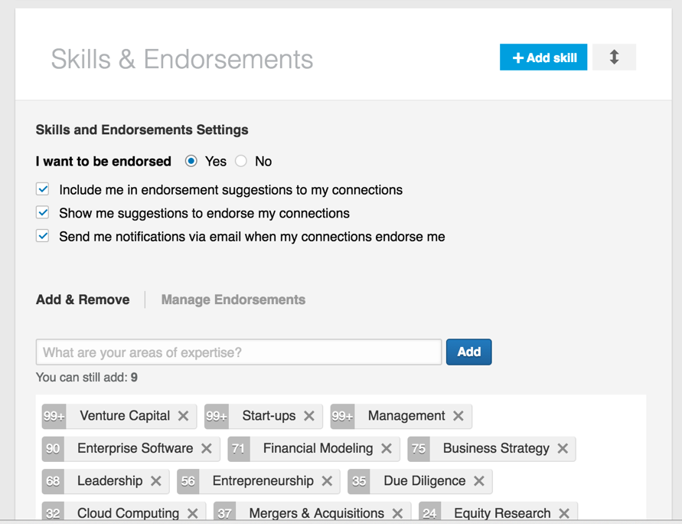

**Next Step: Please watch the next video in the course before doing the next exercise. Thanks**

## **Section #37:**

## ENDORSING PEOPLE ON LINKEDIN AND WHY YOU SHOULD DO THIS

## **exercise #37.2:**

## Endorsing Your contacts

We want to endorse our contacts so they can endorse us. You give and you receive.

Per image below, click on the down arrow of the person you want to endorse.

Then you can enter new key words to endorse this person for.

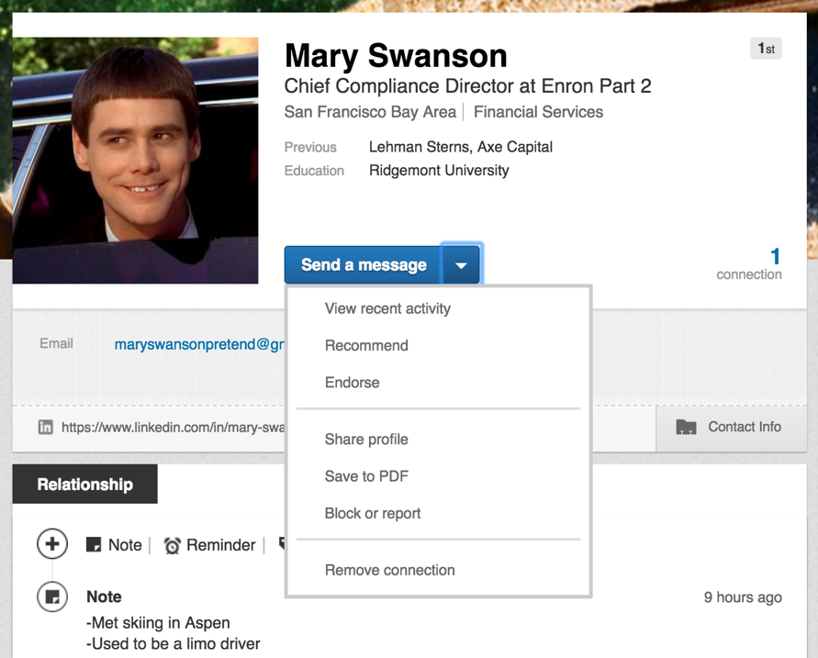

If you want to endorse this person for things I have already endorsed them for : ) then scroll down and click plus on the items you want to endorse them for, per the picture below.

Here you can see the picture of the person or people that endorsed this person for a particular skill.

The exercise here is I want you to endorse 10 people.

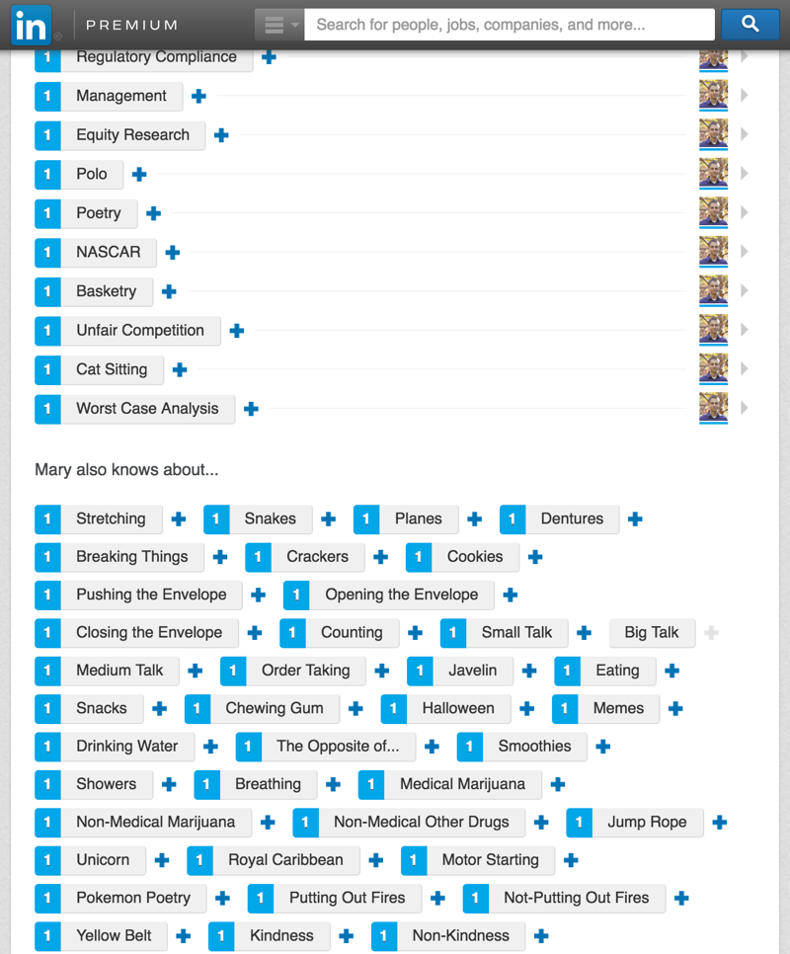

**Next Step: Please watch the next video in the course before doing the next exercise. Thanks**

## **Section #38:**

## Why We All Must Become Journalists in Order to Network: I Will Teach You How

## **exercise #38:**

## Create a Linkedin Post on “Pulse”

We will create an article and save it as a draft on LinkedIn’s “Pulse.” Publish the draft after you have finished perfecting your LinkedIn profile in this course and after you have slept on it for a night. Read it the next morning. If it still feels like you wrote it from your **heart** and you get **chills** that it is so incredibly good, then post it.

Here are the 13 rules to try to adhere to in writing this and all articles:

**1: Write from your heart and enjoy it.**

* If it feels like work, don’t do it.
* You will have these incredibly inspirational moments where you get out of bed to write or you pull over into a parking lot and feel truly inspired that you start writing about something that can help other people with in business (You’ll know what I mean when it happens to you and it will happen I promise you. It’s like the opposite of writer’s block. It feels like in that movie Jerry Maguire when he wrote a business plan all night…or in the Bradley Cooper movie Limitless when he can’t stop writing).

**2: Paragraphs in articles that you write should never have more than 3** **sentences**.

* + Nobody has the attention span anymore to read long paragraphs as you are competing with many screens.

**3: Don’t use really big impressive words.**

* + When I go on vacation I read USA today that more people read or local papers instead of the Economist.

**4: The image that you use in the article has to inspiring or engaging.**

* + People judge a book by it’s cover in this digital age.

**5: The title has to be incredibly engaging too and simplistic if possible.**

**6: Listing numbers in headlines helps a lot.**

* + For example, “7 Ways to Improve You Life.” etc.

**7: If you want, link to other articles that other people have written**

* + I don’t do this much on LinkedIn but I guess some people call it…journalistic bartering as other journalists might also link to your article. People do this a lot with their websites too to increase traffic and for search engine optimization reasons.

**8: Try to keep your article to less than 800 words.**

**9: Why write this now and why you?**

* + I had lunch recently with the head of new media at LinkedIn and she told me that the posts that do the best on LinkedIn answer the questions: ”Why are you writing this now and why are you the best person to wrote this?” Mention examples in your life when you write to reinforce the fact that you should be writing this article.
  + You will get more people to like and share and comment and more traffic on articles that are timely given a news event like the release of a new Apple product etc.

**10: Use right now words like MUST or TODAY or NOW.**

**11: Use Big Names in the Title or in the Article**

* + I have included names like Steve Jobs or Matthew McConaughey which leads to higher reposts, likes, comments and traffic.

**12: Use special words like Tricks, Tips, Secrets, Awesome, Amazing, Crucial etc.**

**13: Make sure to provide a hyperlink to a source to show that you did your research.**

How do you publish a post on LinkedIn Pulse? Please see the image on the next page:

Per this image – go to your profile page and click “write a new post.”



Please see the next page for the next step.

Then per this next image find a superb picture, write a knock out headline, write your inspiring article and then click save. You can send it later (sleep on it always).



**Next Step: Please watch the next video in the course before doing the next exercise. Thanks**

## **Section #39:**

## Following SUCCESSFUL People on LinkedIn

## **exercise #39:**

## Following People on LinkedIn

Select at least 10 people to follow on LinkedIn and consider liking, commenting on or reposting their articles every now and then.

Go to the bottom part of your profile and select customize news per this image.

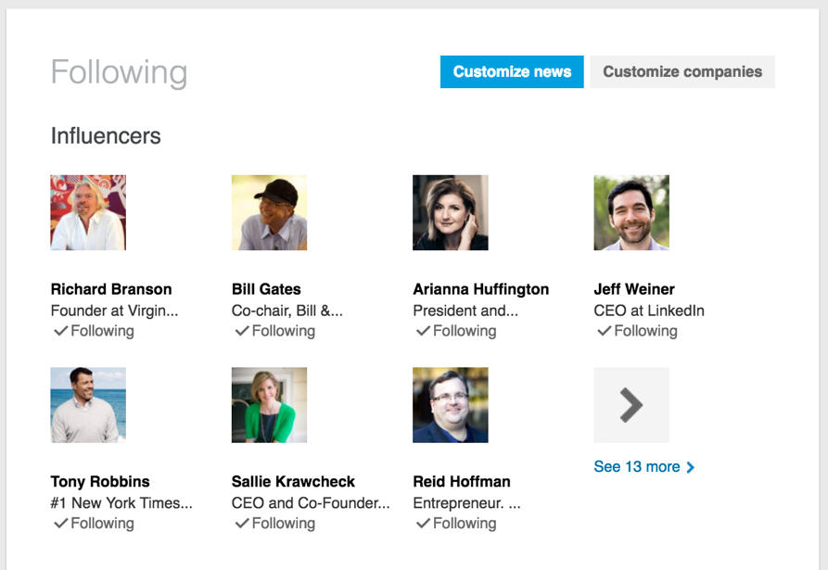

Please see the next page for the next step.

Then per this next image select the people and news sources you would like to follow.

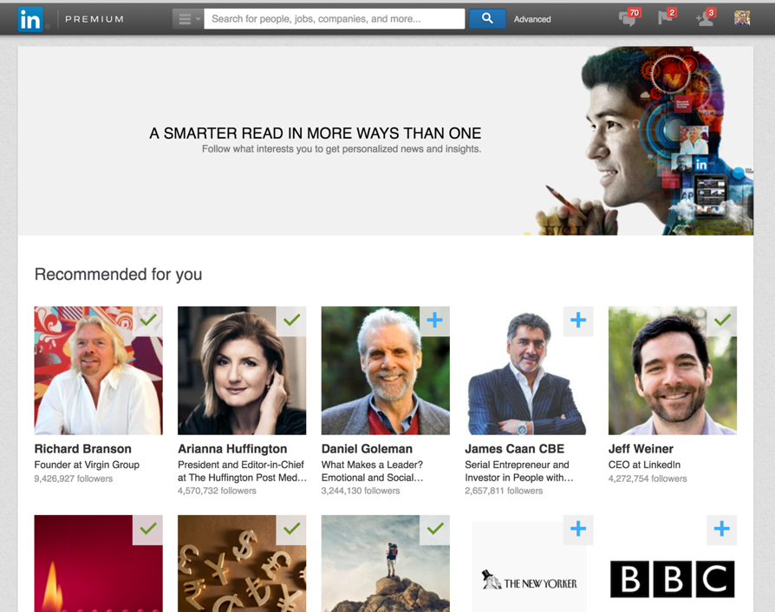

**Next Step: Please watch the next video in the course before doing the next exercise. Thanks**

## **Section #40:**

## Secrets to Get Recruiters and People You Want to Work For Notice You **exercise #40.1:** Joining Many LinkedIn Groups

Join 20+ groups in this exercise as recruiters often search these groups for candidates.

**Step 1:** Per this image, near the bottom of your LinkedIn profile you will see Groups. Mouse over the top right hand corner and select “Manage”.



Please see the next page for the next step.

**Step 2**: Per this image, select discover.



Now you can find and join new groups and you can also find out which ones of your contacts are already member of a particular group which can be helpful.

Please start by joining 20 groups in this exercise.

**Next Step: Please watch the next video in the course before doing the next exercise. Thanks**

## **Section #40**:

## Secrets to Get Recruiters and People You Want to Work For Notice You **exercise #40.2:** SEO and Keyword Hacking on Your LinkedIn PROFILE

**Step 1**: In this exercise which is optional, play around with your title at the very top of LinkedIn. For example, change it from “Associate” to “Technology Investment Banking Associate” or to “Investment Banking Associate | Technology | Media | Telecom” per this image.

Please see step 2 on the following page.

**Step 2**: then play around with how high up in the rankings you are when you search for those items during an advanced keywords and or title search in this image as we are trying to optimize our profile to show higher up in the search rankings



**Next Step: Please watch the next video in the course before doing the next exercise. Thanks**

## **Section #40:**

## Secrets to Get Recruiters and People You Want to Work For Notice You

## **exercise #40.3:**

## Now Let's Add Many Contacts to Our Profile!

Now that your profile is rock solid, let’s add many contacts.

**Step 1**: per the image below, select add contacts.



Please see the next page for the next step.

**Step 2**: enter in an email address per the supported email services on the right side and import away!



From now on after every person you meet in business one on one or in a group setting and of course after an interview, add all of these people to your profile! : )

**Congratulations**!!!! You now have an AMAZING resume and optimized LinkedIn profile!!!

There are no limits to what you can achieve!

If you are taking this course in order, please watch the next video (Part 3 of 3) to start learning about how to network like a rock star!

Thank you very much for your time, dedication and commitment,  
Chris : )



***Please find your passion and live love life on your terms.***